Changing a 09053390 to 05870220

Step 1

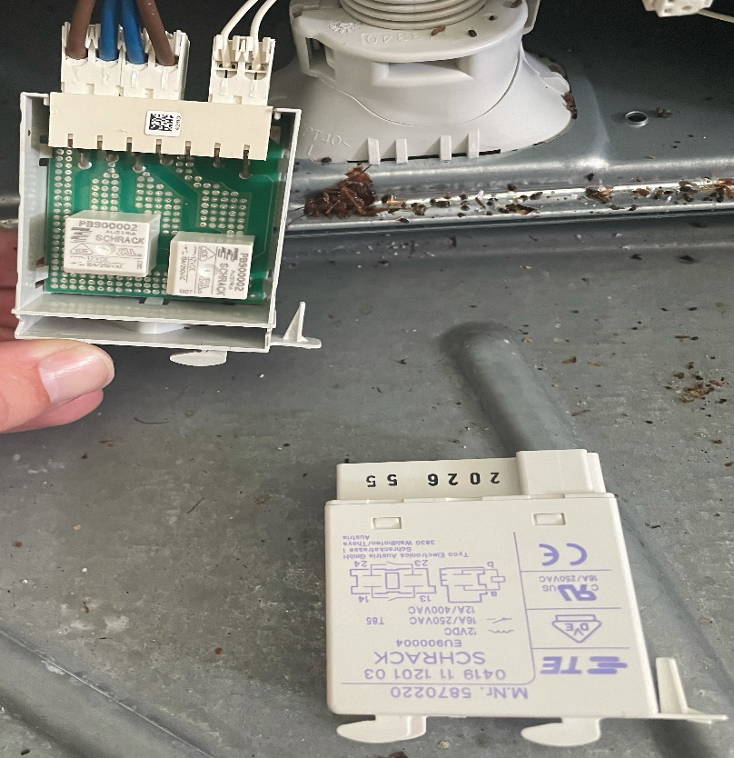

Step 2

Step 3

Step 4

